1. **Basic Info**

Indian Premier League Stats Viz

**Team Member 1**

**Name**: Brett Reeder

**uID:** u0921074

**Email**: [BrettReeder63@hotmail.com](mailto:BrettReeder63@hotmail.com)

**Team Member 2**

**Name**: Srivathsan Gomadam Ramesh

**uID**: u1208099

**Email:** [srivathsangr16@gmail.com](mailto:srivathsangr16@gmail.com)

**Team Member 3**

**Name**: Abhinandan Baireddy

**uID**: u1210208

**Email**: [abhi.baireddy@utah.edu](mailto:abhi.baireddy@utah.edu)

**Project Repository:** https://github.com/breeder88/visproject

1. **Background and Motivation**

The IPL (Indian Premier League) is the world’s largest cricket league in terms of attendance, and is the sixth most attended sports league in the world, with a value of $6.3 billion. In the IPL, 11 Indian teams compete with each other in a group stage, earning 2 points per win. The top 4 teams compete in a final bracket. While many visualizations exist for sports such as basketball (march madness especially) and football. Most of the statistics of IPL cricket games are simply located in tables with queries. While this is useful for finding specific stats, these formats are not easily digestible, nor do they offer the ability to directly compare teams or players.

The present project aims to analyze IPL match data from the beginning of the IPL (2008) to 2016. Both teams and key player stats will be visualized over the seasons, offering team comparisons and visualizations for performance over multiple seasons. Current visualizations don’t offer this format for viewing the data, so visualization of statistics over time, as well as comparisons, would be welcome.

1. **Project Objectives**

This visualization project aims to analyze the patterns in team and player performance within a season and between multiple seasons. Both top batsmen and top bowlers will be listed for teams that play against each other, allowing for the user to see which players consistently perform well in each team.

1. **Data**

Player and match data from 2008 to 2016 was retrieved from github: <https://gist.githubusercontent.com/masterofpun/b66ce9311cc27946d0597dbe1bc8833a/raw/ipl_stats_2016.json>

The data is in the form of a json, which contains an array of games. Each game has player data for each round, from which the relevant stats can be derived. Season long stats for wickets and runs should be tracked for all players, and ranked for each game, where the top players may be shown for every game.

1. **Data processing**

Player stats must be calculated from game stats over all games for season stats, aggregating player information for visualization. Season-long stats for wickets and runs should be tracked for all players, and ranked for each game, where the top players may be shown for every game. In addition, teams should be linked to states, which may be shown on a topojson map of india. Game data will also be compiled into season-long data for ranking teams across seasons.

Since the data is relatively short, season and state data can be obtained from the IPL website. Game and player data may be added to the json file using javascript to process and alter the base json file.

1. **Visualization design**

The data will be displayed in various standard charts and tables, as tables are very good for ranking teams, can be sorted, and have a clear hierarchy. A specialized chart will be developed to display game stats for a selected team, having a central team with each game arrayed around it like spokes on a wheel or marks on a clock.

Bar charts and line charts can be used to compare teams and show players’ performance over time. Comparing bar sizes is a good way of encoding information, and numbers may be added to the bars to further enhance readability and accuracy. Line charts are excellent at showing changes over time, thus will be used to show how top players perform between seasons. A map of india with highlightable states would help to encode teams geographically and creates a compelling centerpiece for the visualization webpage.

1. **Must have features**

Our visualizations must have ways of comparing teams and visualizing top players’ performance over time. Team stats must also be displayed with sorting, as these are crucial to understanding performance during a season. A season timeline is also essential to the visualization, providing an easy way to select seasons. Finally, flashier visualizations are essential, and a custom team selector should be implemented, as well as a map of India to select teams.

1. **Optional features**

Additional useful features may be added, if time permits, including game by game data, player season statistics, and a final 4 bracket. Adding team logos would also make icons more recognizable and compelling and should also be considered for addition. Finally, adding more in-depth player stats that allow for player by player comparison for the top 50 or 100 players would improve the visualization’s usefulness by offering more information on the players, not just the teams.

1. **Project Schedule**

**Oct 28 - Nov 3:** Derive all stats and create any additional data files needed. Implement india map with states colored correctly for each season. Implement season timeline. Create table dataset, derive winners, top batters, top bowlers, and losers from the games dataset.

**Nov 4 - Nov 9 (milestone 1):** Implement the sortable table, implement the team game view, and winner/loser table. Implement team comparison graphs and player stats over time.

**Nov 10 - Nov 17:** Add additional comparison features and consider the optional objectives. Flesh out the process book.

**Nov 18 - Nov 24:** Finish adding any optional features, clean code and write documentation (READMEs, ect).

**Nov 25 - Nov 30:** Create screencast, finish process book with insights, and develop a story from the data.

**Appendix**

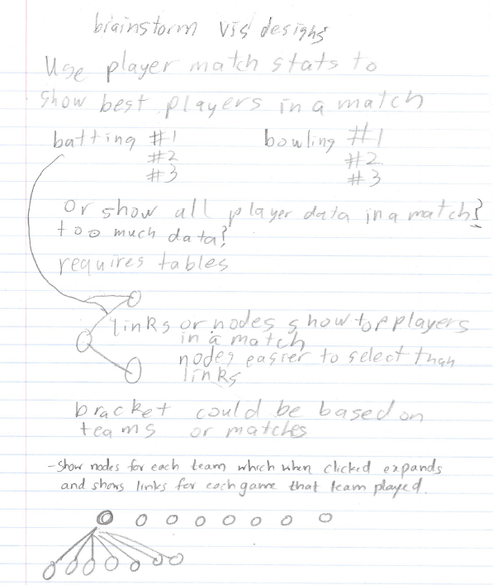

Figure 1. Brainstorm of individual visualization designs.



Figure 2. Potential design 1, page 1.



Figure 3. Potential design 1, page 2.



Figure 4. Potential design 2.



Figure 5 Potential design 3.

Figure 6. Prototype design, page 1.



Figure 7. Prototype design, page 2.